An Observational and Modeling Study of the
Impact of Changing Land Use and Tree Cover on the Weather and Air Quality of the Washington/Baltimore Area
A prospectus prepared for Mr. Gary Allen
Executive Director of the Center for Chesapeake Communities
E-mail: gallenbay@aol.com

by

Dr. Konstantin Vinnikov, Acting State Climatologist for Maryland
Tel: 301-405-5382; Fax: 301-314-9482; E-mail: kostya@atmos.umd.edu

Dr. Da-Lin Zhang, Professor
Tel: 301-405-2018; Fax: 301-314-9482; E-mail: dalin@atmos.umd.edu
Department of Atmospheric and Oceanic Science
The University of Maryland
College Park, MD 20742-2425

Dr. William Stockwell
wstockwell@howard.edu,
Howard University
Washington, DC
202-806-6913

April, 2008

Executive Summary: Changes in land use in the Baltimore/Washington area have resulted in changes in local climate. The mechanism of these interactions is complex, involving surface albedo, transpiration rates, soil moisture and other factors that impact low-level wind speeds, humidity, and temperature. The major air quality problems facing our area, photochemical smog (ozone) and haze (PM2.5) depend strongly on weather and are worse on hotter days. The work proposed here will examine the climatological record to determine the extent and causes of local climate change (Task 1). We will then use that information in a state-of the-art numerical weather prediction model to study potential changes resulting from increases in tree cover and to identify the locations where additional tree cover will be most successful. (Task 2). The next steps will involve Dr. William Stockwell, Professor in Chemistry at Howard University, and Dr. Russell Dickerson, Professor and Director of RAMMPP (funded by MDE and DNR; see http://www.atmos.umd.edu/~RAMMPP) who will use the meteorological fields generated in Tasks 1 & 2. They will use past observations and simulations of future climate in air pollution models such as CMAQ and RADM to determine the impact of changing tree canopy on photochemical ozone and aerosol production.
Task 1: Evaluation of Observed and Future Air Temperature Change in the Baltimore-Washington Corridor Related to Urbanization /Deforestation /Reforestation and Global Warming
PI for Task 1: Konstantin Vinnikov, Acting State Climatologist for Maryland
1.1 Introduction to Task 1
We hope that the process of deforestation-urbanization of the Mid-Atlantic States is more or less accomplished. Unless we are able increase tree cover, future changes of our regional climatic conditions will be mostly related to greenhouse global warming. Climate models and IPCC reports provide us with information that can be used to assess future climate. Nevertheless, important information for understanding future climate can be obtained from studying observed climate variations and trends for the past one to two hundred years. The most comprehensive study of climate and its variation at Maryland has been accomplished a hundred years ago. Scientific report (three volumes, more than 500 pages each,) on that study has been published by Maryland Weather Service in 1899, 1907 and 1910. The second volume was totally devoted to the climate of Baltimore and its vicinity. No further research of such a scale on climate change of Maryland and vicinity has been done during the next hundred years. The most important study on developing of the Baltimore-Washington urban heat corridor has been accomplished by Dr. Helmut Landsberg (1979) at University of Maryland and Dr. Arthur Viterito (1989, 1991) at the George Washington University. But these projects have not been continued. Meteorological observation in downtown of Baltimore, MD is often used in analyses of effect of population and surface modification on urban climate (Brazel et al., 2000). Unfortunately, the majority of urban stations has been moved from downtowns of big cities into airports or suburbs and cannot be used to monitor urban climate any more. Fortunately, EPA and Environmental Departments of States governments have organized new specialized networks to monitor ozone and other atmospheric pollutants. The programs of many new stations include hourly meteorological observations that can be used instead of NOAA meteorological data. Satellite observed land surface temperature can be used as additional source information to evaluate urban heat island effects.
NCDC/NOAA scientists developed different approaches for correcting climatic records to exclude effects of urbanization in vicinity of stations (Karl et al., 1988; Peterson and Owen, 2005; Menne and Williams, 2005). Their results can be equally used to evaluate effects of land use on climate.
The State Climatologist Program was created in 1954 by the Federal Government. Federal responsibility (funding) for this Program was terminated in 1973, when NOAA sent a letter to all state governors asking them to establish and to support their respective state climate programs. The University of Maryland at College Park assumed responsibility for the State Climatologist Office for Maryland. The Acting State Climatologist is looking for opportunity to provide his climate research experience and expert knowledge on the regional and global climate change to the citizens of region. We have to use observed regional climate variations during past one, better two, hundred years to correctly evaluate effect of contemporary global warming and land use on regional climate. Figure 1 shows observed changes of Maryland averaged temperature and precipitation for the last hundred years. The changes were much larger in the Baltimore-Washington urbanized area.

Fig. 1. Estimates of observed century scale climatic trends in temperature and precipitation at Maryland. Observed seasonality of trends corresponds to global warming scenario. Temperature is increasing and precipitation is decreasing. But, seasonal variations of temperature and precipitation are both decreasing.

Proposed work on task 1
- Assess regional climate variations at Baltimore-Washington corridor during past one-two hundred years using existing historical climatic records.
- Evaluate contemporary climate change in Baltimore-Washington area that can be attributed to global warming and to regional change in land use.
- Estimate seasonal and diurnal effects of increase tree cover in the Baltimore-Washington area by comparing observations of rural, suburban and urban meteorological stations.
- Assess 21st century change in seasonal and diurnal cycles of air temperature at Baltimore-Washington area related to greenhouse global warming based on IPCC (2007) climate model simulations.
- Present written report and Power Point presentation “Evaluation of Observed and Expected in the Future Air Temperature Change in the Baltimore-Washington Corridor Related to Urbanization/Deforestation/Reforestation and Global Warming”
1.2. Data
- Climatic records accumulated at State Climatologist Office for Maryland.
- NCDC/NOAA. United States Historical Climatology Network data.
- NCDC/NOAA. United States Integrated Surface Hourly Observations.
- EPA and regional Environmental Agencies. Data of hourly meteorological observations at specialized national and regional Air Pollution Monitoring networks.
- WCRP3 multi-model database (IPCC 4th Assessment Model Output database).
1.3. Budget for task 1
Requested budget for this Project is $60,000 for one year: 3 month salary for Acting State Climatologist, Konstantin Vinnikov, $2,000 travel expenses to visit National Climatic Data Center /NOAA and a few regional institutions; $1000 research materials (data disk and software); and the University’s overhead.

References
A. Brazel, N. Selover, R. Vose, G. Heisler, 2000: The tale of two climates – Baltimore and Phoenix urban LTER sites. Clim. Res., 15, 123-135.
T.R. Karl, H.F. Diaz, G. Kukla, 1988: Urbanization: Its Detection and Effect in the United States Climate Record. J. Climate, 1, 1099-1123.
H.E. Landsberg, 1979: Atmospheric changes in a growing community (The Columbia, Maryland Experience). Urban Ecology, 4, 53-81.
N.J. Menne and C.N. Williams, Jr., 2005: Detectio of undocumented Changepoints using multiple test statistics and composite reference series. J. Climate, 19, 2882-2895.
T.C. Peterson and T.W.Owen, 2005: Urban Heat Island Assessement: Metadata are Important. J. Climate, 18, 2637-2646.
A. Viterito, 1989: Changing thermal topography of the Baltimore-Washington corridor – 1950-1979. Climatic Change, 14, 89-102.
A. Viterito, 1991: Future warming for United-States cities. Population and Envir., 13, 101-111.
Reprints of recent publications by Konstantin Vinnikov on climate change can be found in: http://www.atmos.umd.edu/~kostya/Pdf

Task 2: Impact of Increasing Residential Density and Urban Trees on the Surface Climatology over the Washington – Baltimore Metropolitan Region
PI for Task 2: Da-Lin Zhang, Professor
2.1. Introduction to Task 2
It is well known that converting grassland to trees in urban areas will reduce short-wave albedo, long-wave emissivity and runoff, but it will increase soil moisture content, evapotranspiration, surface friction and thermal inertial, thereby affecting the surface climatology (i.e., temperature, winds, moisture and air quality). Previous modeling studies have even shown that properly planted forests could facilitate the generation of precipitation or alter precipitation patterns (Yan and Anthes 1988) due to the changes in the surface frictional convergence and soil moisture. Recent land-surface studies showed that changing landscape could not only alter the surface climatology but also the development of cloud convection (Chen and Avissar 1994). Thus, increasing urban trees appears to be a particular useful strategy when considering the current global warming trend. At issue is to what extent these changes would occur. Some recent modeling studies, using the PSU/NCAR MM5 model with coarse resolution and simple physics schemes have shown the relationship between tree canopy and surface climatology (see Taha 1996, Nowak et al. 2000, Civerolo et al. 2000).
Similarly, when a vegetated land is replaced by asphalt and concrete for roads and buildings, more solar shortwave energy would be absorbed, rather than reflected, and less evapotranspiration would occur, thereby causing surface temperatures and ambient temperatures to increase. As a result, the “urban heat island” effects will be enhanced.
In response to the interest of Maryland’s Department of Environment in investigating the possible impact of increasing urban trees on ozone air quality over the Washington – Baltimore metropolitan region, we have been conducting high-resolution, numerical simulations of meteorological conditions for a 3-day very hot period, i.e., 7 – 10 July 2007, using the coupled modeling system of the Weather Research and Forecast (WRF) model, NCEP’s NOAH land-surface model, and an Urban Canopy Model (UCM) model that was developed by Dr. Fei Chen’s group at NCAR. In this study, we are using the land-use data at 30-m resolution for the urban areas of New York, Philadelphia, Baltimore and Washington, DC, during the year of 2001 that has been analyzed and re-gridded to the scale of 500 m. In this modeling system, NOAH calculates surface fluxes and skin temperature, and update soil moisture and temperature and the other related surface parameters; UCM incorporates the effects of low/high density residential areas (wall, roof), commercial/industrial/transportation (building height and coverage, road) (see Figs. 2a,b,c), urban/rural areas (canopy) and even the anthropogenic activities on roughness, albedo, moisture availability, radiation and heating/cooling in a mosaic way for each grid box, based on the land-use data. We are running the coupled nested-grid (4.5/1.5/0.5 km) modeling system with the finest resolution of 500 m for the Washington-Baltimore Metropolitan region. Preliminary results show that the model captures well the hot skin temperature at major cities and towns as well as major roads on the early afternoons. However, the skin temperatures over forest areas after two days appear to be 2ºC too high. We attribute this warmness partly to the use of the soil information from NCEP’s Global Forecast System, and partly to the neglect of displacement heights for forest in the calculation of surface roughness.
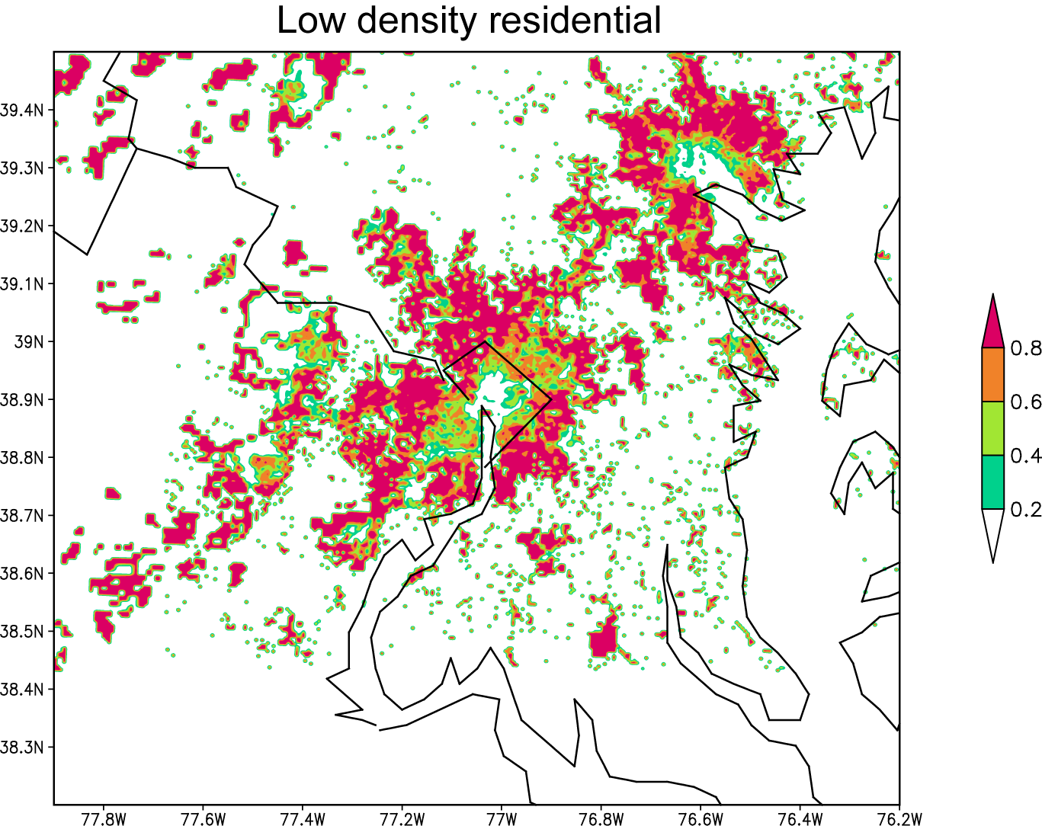 | 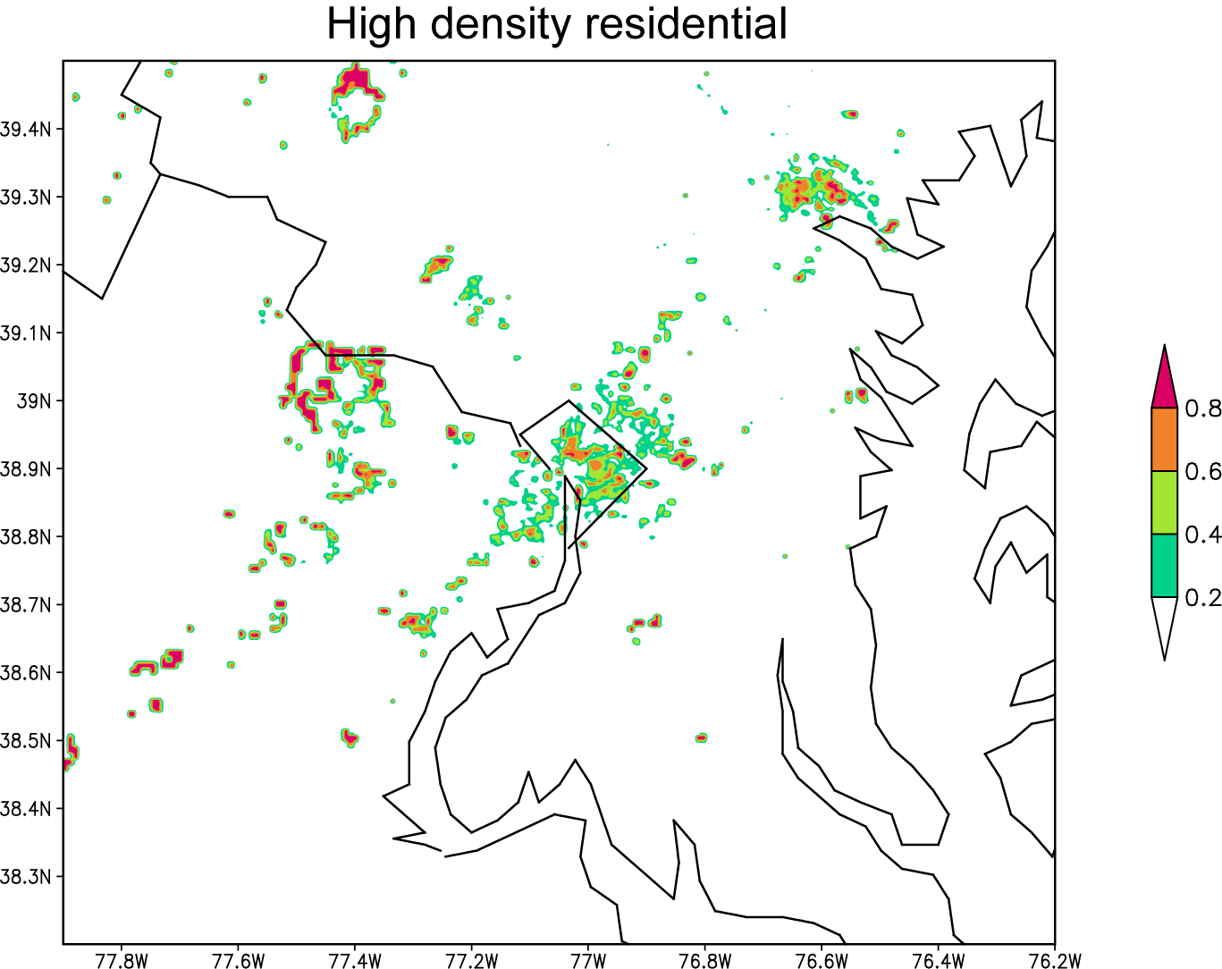
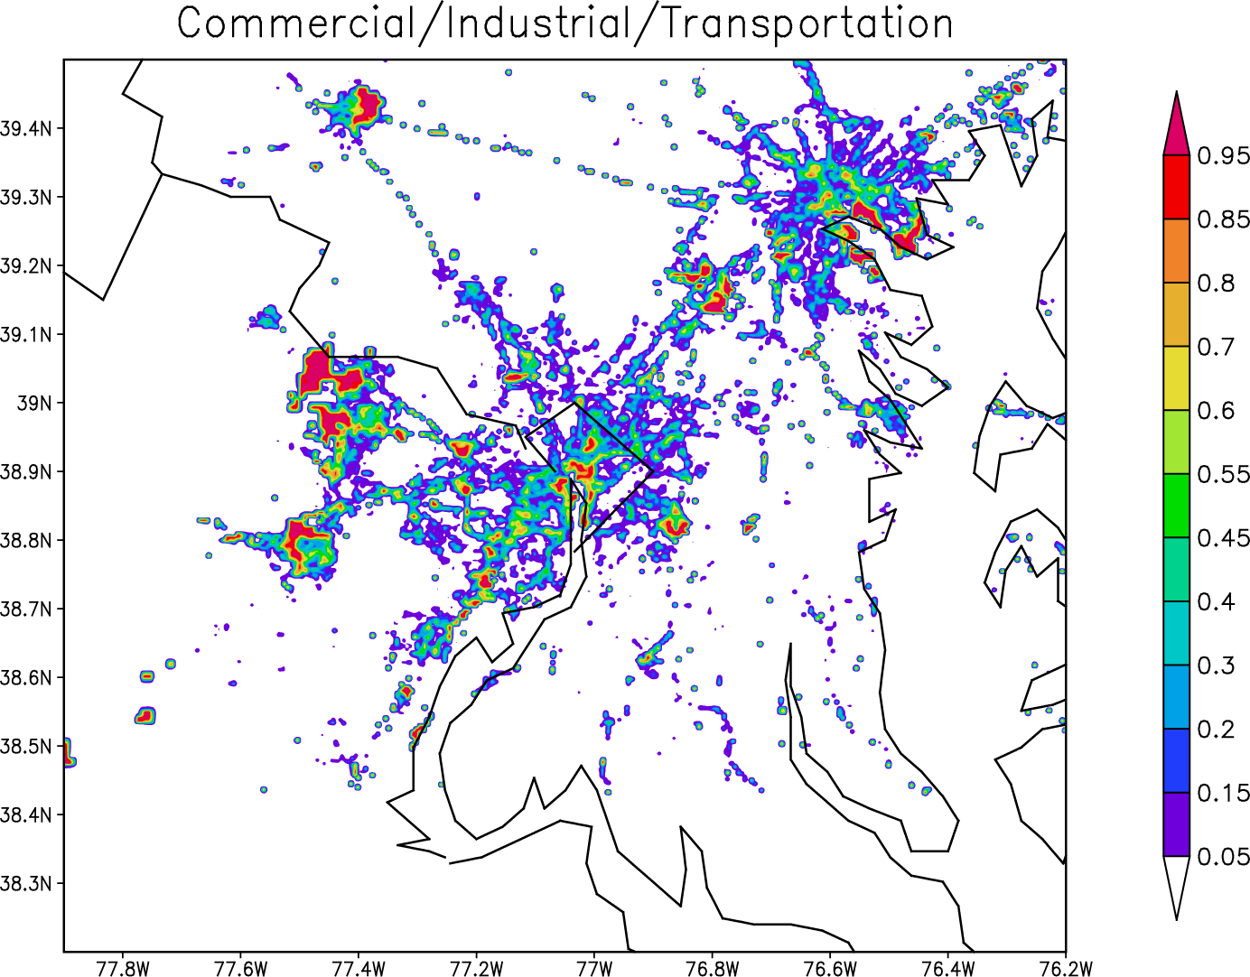 | Fig. 2. Urban land-use maps of three urban categories over the Washington-Baltimore region: (a) low-density residential, (b) high-density residential and (c) commercial / industry / transportation.

2.2. Scope of the work on Task 2
The objectives of this project are to study the impact of increasing tree canopy over the urban area, and expanding or increasing residential area on the surface climatology of the Washington – Baltimore region for two different climate regimes: one during the summer month and the other during the winter month. For each regime, one-week simulations with different hypothetical scenarios will be conducted.
The scope of work includes the following tasks:
a) Verify the model-simulated surface climatology against the MODIS satellite observed, and surface-station observed for the two periods, and quantify the diurnal variation of the urban heat island effects.
b) Assuming that the coupled modeling system can reproduce reasonably well the observed surface climatology, two groups of sensitivity simulations (i.e., a total of 8 one-week simulations) will be conducted. In the first group, the residential coverage will be doubled or the residential density is doubled to simulate the impact of possible expansion of residential coverage, replacing the original vegetated land, over the Washington-Baltimore region. The second group, the tree canopy over the urban areas will be increased by 5% and 10%, respectively, to quantify the effects of tree canopy on the surface climatology and air quality problems over the region. These two groups of sensitivity runs will be performed for the above-mentioned two different climate regimes.
c) The 8 sensitivity simulations will be studied, with respect to the control run, to understand to what extent expanding residential coverage and planting more tree canopy would affect the surface climatology of the Washington-Baltimore metropolitan region.
2.3. Deliverables
After completion of this study, we will provide a report of the results and PowerPoint presentations, including the meteorological flow structures, regional climate scenarios, the time series of maximum and minimum surface temperatures, winds and moistures, and changes in the surface climatology. All the model data will be released to any user if necessary for studying any environmental problems. We expect that a similar document could be submitted for publication in a scientific journal.
2.4. Budget for Task 2
Currently, the PI have received 4-month funds from MDE to support a postdoctorial fellow, Dr. Yixuan Shou, to study the tree canopy issue related to a 3-day simulation of the 7 – 10 July 2007 hot episode using the coupled WRF-NOAH-UCM model. For the current project, we would like to request a 6-month postdoctorial support (i.e., $40 K) plus $4 K funds for additional CPUs in order to run the modeling system at such a high resolution and for a longer times.
See http://www.atmos.umd.edu/~dalin/vita.html for the bibliography of Prof. Da-Lin Zhang.

References
Chen, F. and R. Avissar, 1994. Impact of Land-Surface Moisture Variability on Local Shallow Convective Cumulus and Precipitation in Large-Scale Models. J. Appl. Meteor., 33:1382-1401.
Civerolo, K., Sistla, G., Rao, S.T., and Nowak, D.J. 2000. The effects of land use in meteorological modeling: implications for assessment of future air quality scenarios. Atmos. Environ., 34, 1615-1621.
Nowak, D. J., Civerolo, K. L., Rao, S. T., Sistla, G., Luley, C. J., and Crane, D. E., 2000. A modeling study of the impact of urban trees on ozone. Atmospheric Environment 34, 1601-1613.
Taha H, Konopacki, S. and Gabersek S, 1999. Impacts of large-scale surface modifications on meteorological conditions and energy use: A 10-region modeling study. Theo. and App. Climo. 62 (3-4): 175-185.
Yan, H. and R.A. Anthes, 1988: The effect of variations in surface moisture on mesoscale Sclimcirculations. Mon. Wea. Rev., 116, 192-208.

Budget Summary (Estimated)

Personnel
Vinnikov 3 mo (inc. fringe bene’s) $38,000
Shou 6 mo (inc. fringe bene’s) 26,800
Travel 1,000
Research Materials 500
Equipment (additional CPU’s) 4,000
Infra-red imaging and analysis 25000

Total direct costs 95,300

Indirect costs (49%) 46,697

Total $141,997

