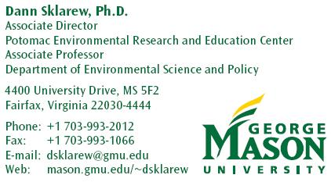
On the path to Copenhagen,
A teachable moment to galvanize communication on climate change
In the National Capital Region

- We need to focus the public and ourselves on how to address both controllable and "uncontrollable" sources of GHG emissions in our region.
- To this end, we have a "teachable moment" between now and December (Copenhagen talks) when media is primed to help us reach the local public.
- Recent and expected Chesapeake Bay ecological changes, in particular, provide a focal point for communicating local impacts of climate change.

Rationale
- We are committing in the Region to voluntarily realize substantial "uncontrollable" GHG reductions on an ambitious schedule. As shown in the NCR Climate Change report (figure 12, p41), more than a half of our 2020 emission reduction goal remains uncontrolled (i.e. non-attributable to known or expected policies).
- Locally, we have a climate change crisis with respect to Chesapeake Bay restoration. This should be a local focus for efforts to convey imperative for GHG reductions, and to galvanize public support.
- We need to enact a prompt and serious social marketing strategy, with clear and poignant messages to convey issue #2 (as well as other local impacts) and effectively address issue #1, in order to catalyze stakeholders’ and residents' attention, concern and rapid actions above and beyond current levels achievable [or controllable] by government policy-making alone.
Proposal for a Catalytic Communication Strategy
Between now and COP, we have an opportunity to focus a few succinct messages to try to positively impact behavior while people are paying attention:
- How does global warming affect you here and now (e.g., Chesapeake Bay).
- While global leaders are negotiating, local jurisdictions in the region are moving ahead through {example programs}
- Even so, we can't do it without your help (i.e., there's a lot still "uncontrollable")
- What you can do now (CFL bulbs, house caulking, duct sealing, alternative transportation modes etc.)
- What you should do as soon as you can (energy efficiency audits and retrofits, solar, fuel-efficient car, move closer to your workplace, etc.)

Proposed options: Prepare one or more of the following
- Talking points for local officials.

- Scripts or materials to be published in local papers or newsletters and/or presented as radio or TV public service announcements

- A coordinated social marketing campaign.

