Street Smart Spring 2009 Public Awareness Campaign
Materials Order Form
The following materials are available for the 2009 Spring Street Smart Campaign. Please indicate if you are interested in receiving any of the materials and, if so, which items and how many of each. Please note the campaign produces a limited amount of materials and we will do our best to fulfill requests within our budget.
Please email this form to Rachel Lyons at Rachel@mcandrewcompany.com or fax a copy to 301-913-5484. Make sure to include your name, address and phone number in the email/fax for delivery purposes.
DEADLINE FOR REQUESTS: FEBRUARY 27, 2009 AT 12:00 P.M.

Materials: | Order:
Safety Tips Brochure:  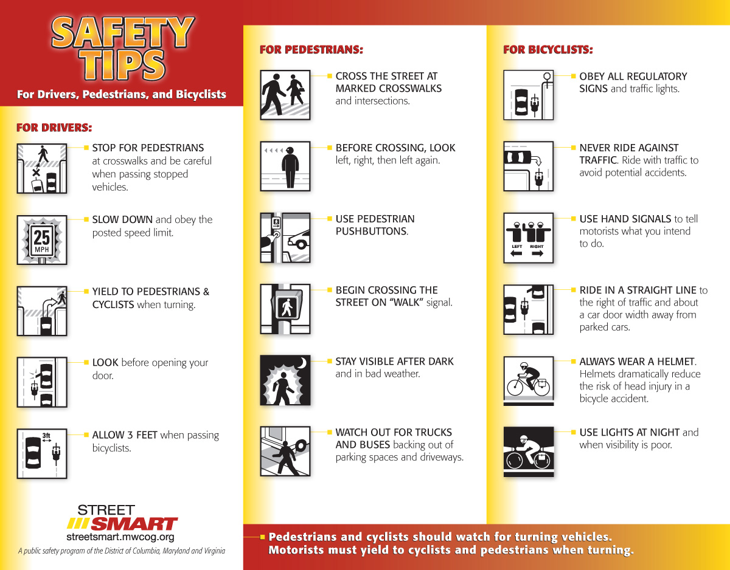  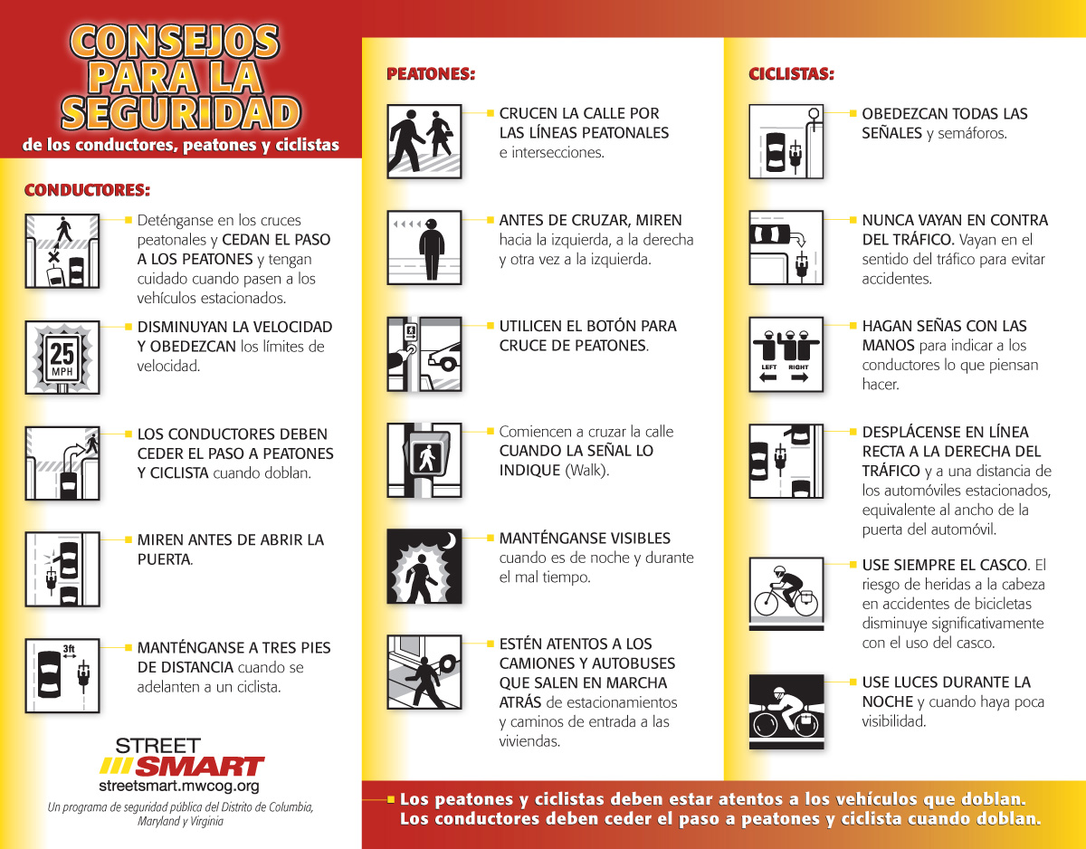 | Brochure Size:  - 10.875” x 8.5” flat folding to 3.625” x 8.5”  Requested Quantity: ______________
Crosswalks Handout:  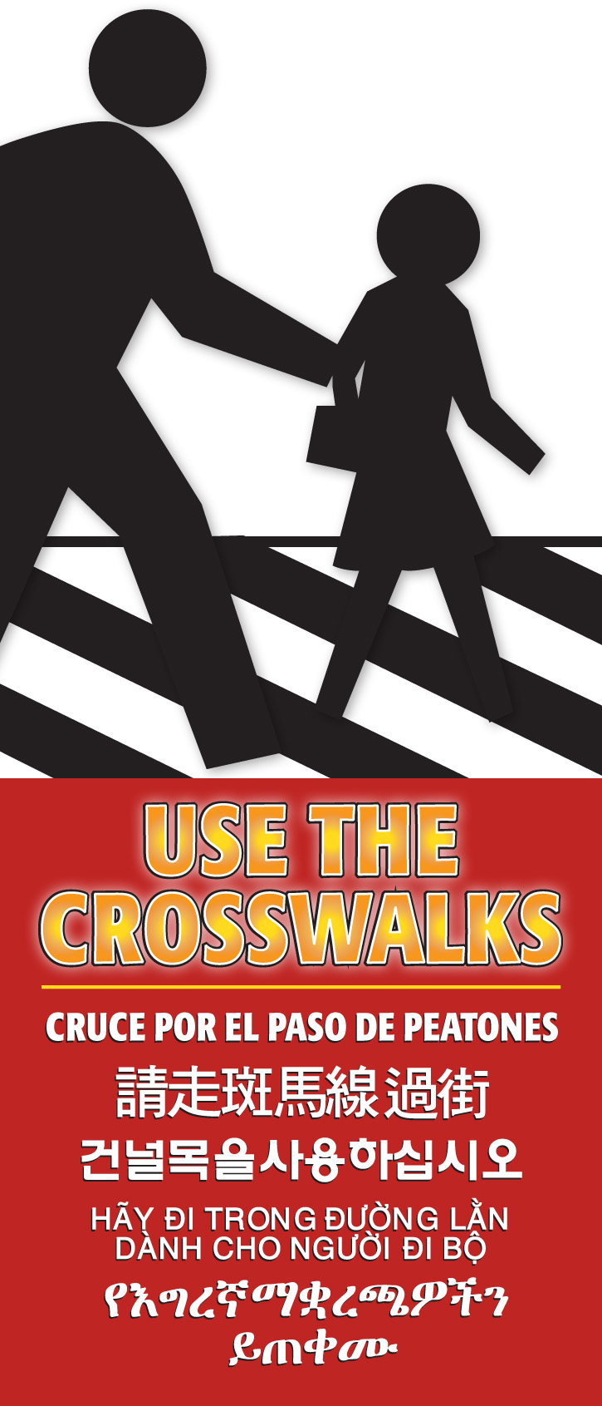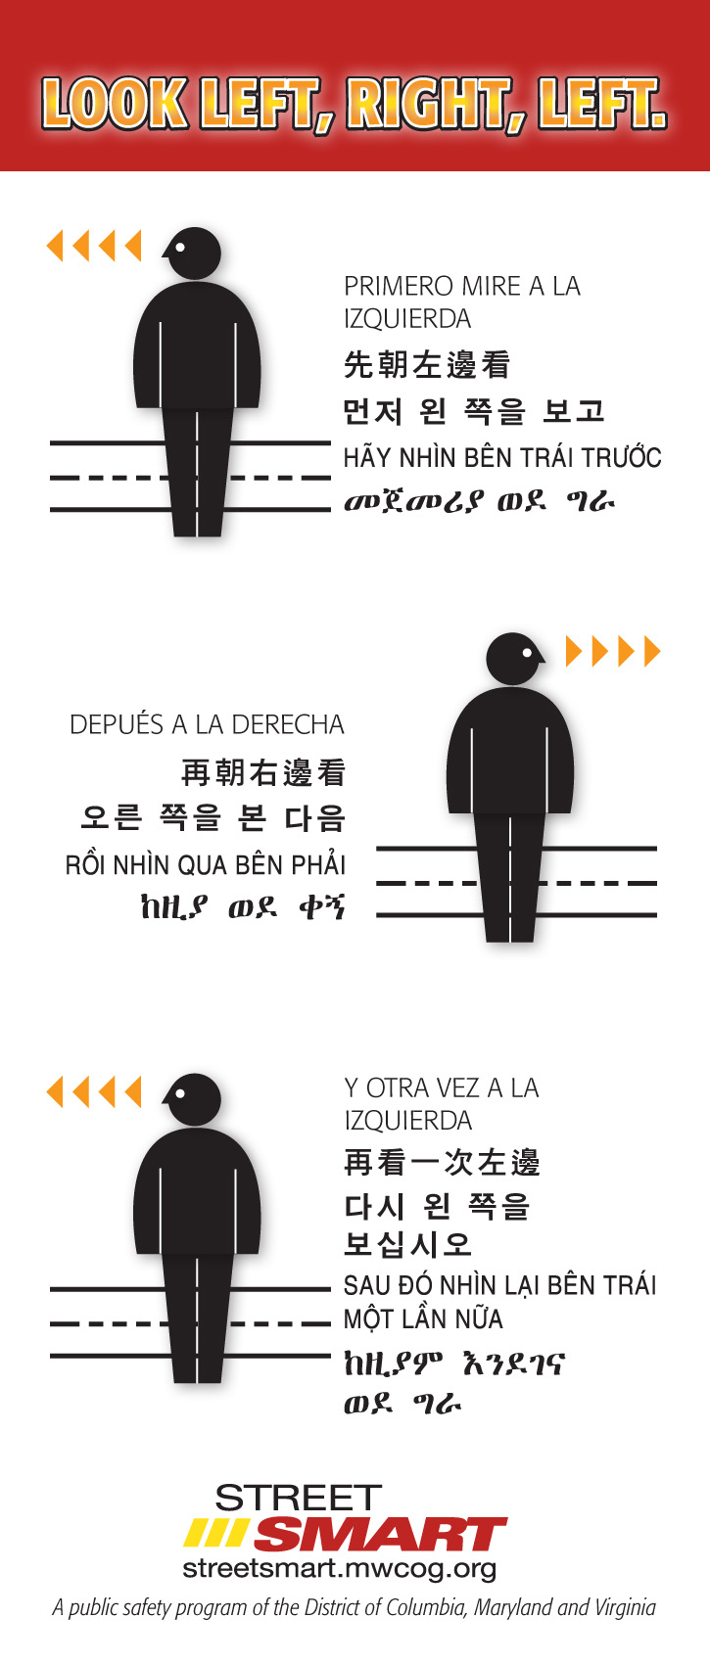 | Handout Size:  - 3.625” x 8.5”  Requested Quantity: ______________
Poster #1: Wait for the Walk  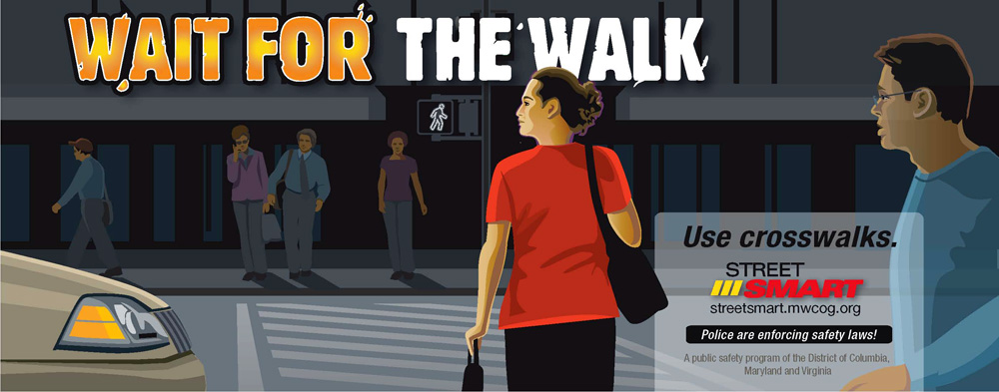 | Poster Sizes (artwork will be reconfigured to vertical format):  - 11” x 17” OR 22” x 28”  Requested Quantity: ______________  Please indicate which size.
Poster #2: Yield to Pedestrians When Turning   | Poster Sizes (artwork will be reconfigured to vertical format):  - 11” x 17” OR 22” x 28”  - Requested Quantity: ______________  Please indicate which size.
Poster #3: Obey Signs and Signals  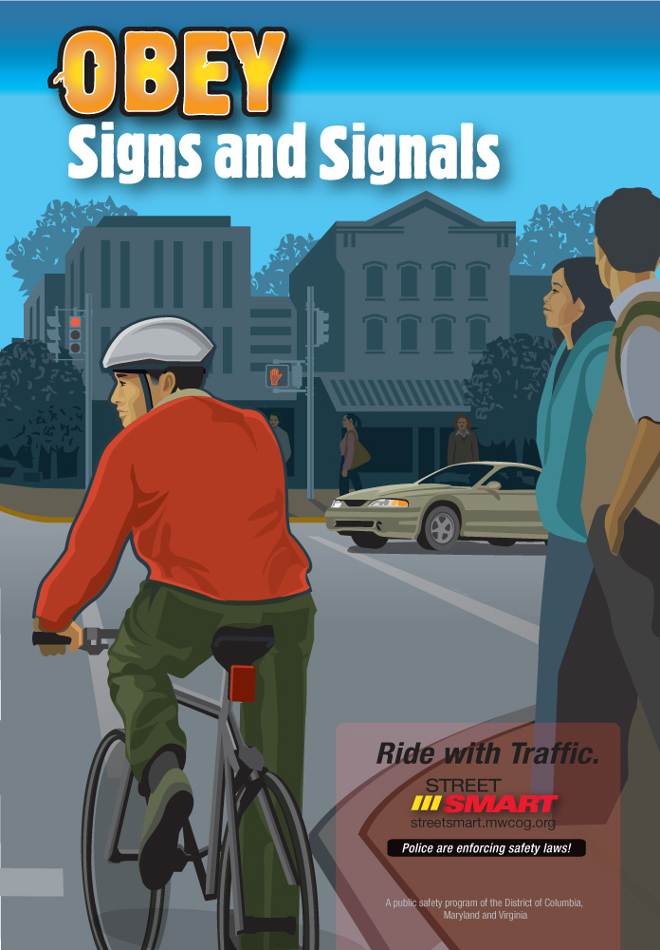 | Poster Sizes:  - 11” x 17” OR 22” x 28”  - Requested Quantity: ______________  Please indicate which size.
Poster #4: Cross After the Bus Leaves the Stop  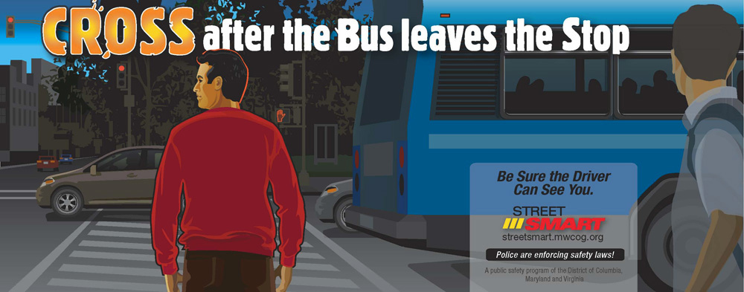 | Poster Sizes (artwork will be reconfigured to vertical format):  - 11” x 17” OR 22” x 28”  - Requested Quantity: ______________  Please indicate which size.

Delivery Information:
Name: __________________________________________________
Organization: ____________________________________________
Address: ________________________________________________
Phone Number: __________________________________________
Email: ___________________________________________________

