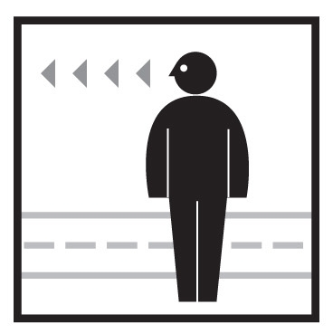

Washington Regional
Pedestrian and Bicyclist Safety Enforcement Seminar
Thursday, August 28th, 2014

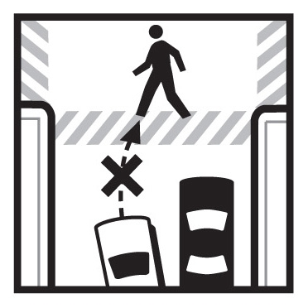

Date: Thursday, August 28th, 2014

Time: 9:30 a.m. to 12:00 p.m.

Place: COG Board Room, Third Floor
777 North Capitol Street NE, Suite 300
Washington, D.C. 20002

DRAFT Agenda

Lunch will be made available at Noon.

1. 9:30 a.m. Welcome, Introductions, and Opening Remarks
- Michael Farrell, Transportation Planner. National Capital Region Transportation Planning Board (TPB)

2. 9:35 a.m. Pedestrian Safety in the Washington Region and the Street Smart Program
- Michael Farrell, Transportation Planner, TPB

3. 9:50 a.m. DDOT/DCMPD Pedestrian-Bicycle Safety Program
- George Branyan, Pedestrian Coordinator, DDOT
- TBD, DCMPD
  - Pedestrian and Bicycle Crash Types
  - Applicable Laws
  - Effective Enforcement Techniques
  - DC’s Pedestrian and Bicycle Enforcement Program

4. 10:50 a.m. BREAK

5. 11:00 a.m. Montgomery County Pedestrian Safety
- Jeff Dunckel, Pedestrian Safety Coordinator, Montgomery County DOT
  - Results of the Montgomery County Pedestrian Safety Initiative
- TBD, Montgomery County Police
  - Pedestrian Enforcement Program

5. 11:50 a.m. Discussion/Adjourn for Lunch



