

Report to Baltimore Gas & Electric
Demand-Side Management Program
Benefit/Cost Analysis

Submitted To:

Baltimore Gas & Electric

January 28, 2008



Submitted to:
Ruth Kiselewich
Director – Special Projects & Supplier Services
BGE
2 Center Plaza
110 W. Fayette Street, 2nd Floor
Baltimore, MD 21201
410.470.1361

Submitted by:
Summit Blue Consulting, LLC
1722 14th Street, Ste. 230
Boulder, CO 80302
720.564.1130

Prepared by:
Marshall Keneipp, Principal
720.564.1130
mkeneipp@summitblue.com

Gerry Meade, Senior Consultant
416.566.8616
gmeade@summitblue.com

Stu Slote, Consultant
802-860-0017
sslote@summitblue.com
Table of Contents
1. Introduction 3
2. Approach to Cost-Effectiveness Analysis 3
3. Summary of Benefit/Cost Evaluation Results 5
4. Energy Efficiency Measure Analysis Inputs and Assumptions 6
5. Benefit/Cost Analysis Data Inputs and Assumptions 9
6. Summary of Programs Benefit/Cost Analysis Results 12
6.1 ENERGY STAR® Products 12
6.2 Residential Gas and Electric HVAC 14
6.3 Residential Retrofit 15
6.4 Residential New Construction 17
6.5 Low Income 18
6.6 Small Commercial 20
Appendix A: Program Benefit / Cost Analysis Details 21
Appendix B: Measure Analysis Spreadsheets (MAS) 47
Appendix C: Measure Cost Data Summary 90
Appendix D: Program Administration Cost Data Summary 93
Appendix E: Market Penetration Summary 95
Appendix F: Building Energy Simulation Model Specifications 98

List of Tables
Table 3-1: Summary of Benefit/Cost Analysis Results 5
Table 3-2: 2015 Cumulative Annual Reductions 6
Table 4-1: Summary of Measure Life Estimates 7
Table 4-2: Seasonal Time Period Breakdown 8
Table 5-1: Avoided Cost Assumptions 9
Table 5-2: BGE Customer Billing Rates 10
Table 5-3: BGE Customer Base 11
Table 6-1: Summary of Energy Star Products Measures 12
Table 6-2: Summary of Impacts Energy Star Products 13
Table 6-3: Summary of Residential Gas and Electric HVAC Measures 14
Table 6-4: Summary of Impacts Residential Gas and Electric HVAC 14
Table 6-5: Summary of Residential Retrofit Measures 15
Table 6-6: Summary of Impacts Residential Retrofit 16
Table 6-7: Summary of Impacts Residential New Construction 17
Table 6-8: Summary of Low Income Program Measures 18
Table 6-9: Summary of Impacts Low Income Program 18
Table 6-10: Summary of Small Commercial Measures 20
Table 6-11: Summary of Impacts Small Commercial Program 20

1. Introduction
This document provides the results of the revised cost-effectiveness analysis for BGE’s DSM programs. The revised analysis incorporates the comments, suggestions and findings resulting from the stakeholder meetings held on January 4th, 10th, 18th , and 25th 2008. The revised analysis includes a re-structured benefit/cost methodology that incorporates BGE’s seasonally differentiated avoided costs, and reflects the results of a comprehensive review of input assumptions to the benefit/cost models.
The six programs included in this analysis:
- Energy Star Products
- Residential Gas and Electric HVAC
- Residential Retrofit
- Residential New Construction
- Low Income
- Small Commercial

2. Approach to Cost-Effectiveness Analysis
A cost-effectiveness analysis was conducted for each of BGE’s proposed DSM programs. The methods, procedures and data inputs involved in conducting DSM benefit-cost analyses are specified in the California Standard Practice Manual: Economic analysis of Demand-Side Programs and Project. The analysis produced results for the four standard benefit cost tests: 1. Ratepayer Impact Measure (RIM) Test, 2. Participant Test, 3. Program Administrator Cost Test, and 4. Total Resource Cost (TRC) Test. In addition some analysis was applied to assessing program performance from the perspective of the Societal Cost (SC) Test. The SC Test is a variant of the TRC Test and incorporates additional societal benefits such as environmental benefits. The avoided cost data used in the Societal Cost Test included an environmental benefits adder of $0.0115/kWh and a societal discount rate of 5.00% was used.
Cost-effectiveness analysis of DSM program is a systematic process that requires a broad range of data inputs and methodical assessment of program savings and costs over time. The process for conducting cost-effectiveness analysis entails the following steps:
- Identify measures suitable to BGE’s residential and small commercial markets.
- Develop measure performance specifications include baseline and energy efficient performance characteristics.
- Analyze non-coincident and coincident peak summer demand, annual energy savings (including kWh and/or Therms), measure life, and installed/incremental measure cost for each measure.
- Estimate market penetration values for each measures for each program to determine the program savings potential.
- Conduct a benefit/cost analysis for each program using the methodology described in the California Standard Practice Manual.
Data required for the benefit/cost tests includes annual utility avoided cost data, financial data such as discount rates, program administration costs, energy efficiency measure demand and energy savings, energy efficiency measure lifetimes, customer incremental and installed costs, customer billing rates, and estimates of market penetration of measures promoted by the program. The overall process of conducting cost-effectiveness analyses is depicted above in Figure 2-1.
Identify EEMs
Develop EEM Specifications
Estimate Individual EEM Savings and Costs
Estimate Program Market Penetration and Implementation Costs
Estimate Total EEM Market Penetration, Savings and Cost, and Program Implementation Cost
Estimate EEM Market Penetration, Savings and Cost, and Program Implementation Cost by Program Year
Conduct Benefit/Cost Analysis Using Standard Tests
Measure Cost Data
Benefit/Cost Test Results
Measure Analysis Spreadsheets (MAS)
B/C Analysis Workbooks
Figure 2-1: Program Benefit/Cost Analysis Methodology
Each step in this process is described below and the appendices provide detailed data and assumptions on the individual measure analyses, customer incremental/installed costs, and the inputs and outputs of the benefit/cost models. Electronic versions of the Measure Analysis Spreadsheets and Benefit/Cost Analysis Workbooks have been provided to BGE.

3. Summary of Benefit/Cost Evaluation Results
Table 3-1 below provides a summary of the benefit/cost test results for 2008-2015 for each program from the perspectives of the Total Resource Cost (TRC) Test and the Societal Cost (SC) Test, and the corresponding total energy (kWh, kW and Therms) and emissions (CO₂, NOx and SOx) savings. These results provide total lifecycle electric energy savings of over 10 billion kWh and almost 200 thousand therms. Program actual costs total almost $275 million for the eight year portfolio. The cost of saved energy is $0.0264/kWh (nominal dollars). The total conservation portfolio has a TRC ratio of 2.35 and a SC ratio of 3.03. The TRC ratios range from a high 4.82 for the ENERGY STAR Products Program to a low of 1.14 for the Low Income Program. The portfolio will result in lifecycle emissions savings of almost 8 million tons of CO2, over 14 thousand tons of NOx, and over 44 thousand tons of SOx.

Table 3-1: Summary of Benefit/Cost Analysis Results
Table 3-1 below provides a summary of cumulative annual reductions in the last year of the eight year portfolio. In 2015, energy reductions are estimated to be 950 million kWh, 155 MW and 11 million therms. Projected emissions reductions in 2015 are 675 thousand tons of CO2, 1,285 tons of NOx, and 4,000 tons of SOx.

Table 3-2: 2015 Cumulative Annual Reductions

4. Energy Efficiency Measure Analysis Inputs and Assumptions
Estimates of demand and energy savings for each energy efficiency measure to be promoted by the programs are required for the benefit/cost analysis. The data sources and assumptions used in the analysis are described below.
4.1 Measure Analysis Data Sources and Assumptions
Measure Savings Analysis and Input Assumption
Measure savings calculations are based on energy performance assumptions about the baseline and energy efficient conditions for each technology for each measure, operating hours, coincidence of demand savings with utility system peak, and other variables. The details of the assumptions and the energy savings analysis for each measure are provided in the Measure Analysis Spreadsheets (MAS) contained in Appendix B. The MAS also include the customer incremental (for new construction or replace on burnout applications) or installed (for retrofit situations) cost for each measure and estimates of customer energy cost savings.
In preparing the measure analyses, Summit Blue obtained base case and energy efficiency case data from sources such as Summit Blue’s energy efficiency measure database, manufacturers’ data, other engineering studies and data resources, the study conducted for BGE by ACEEE, and industry recognized sources such as the California DEER Database and ENERGY STAR®. For weather-dependent measures, Summit Blue conducted savings analysis specifically for the BGE service territory using building energy simulation models such as EQuest and EnergyGauge. A description of the building energy simulation model parameters is provided in Appendix F. Where a measure consisted of several options such as insulation levels, Summit Blue assigned a weighting value to each level to obtain average savings per measure. Weighting factors are based on estimated market distributions or sales values and were assigned by Summit Blue based on results from other studies or professional judgment.
Measure Life
The benefit/cost analysis requires computation of the net present value of the benefits of the savings from the measure installation attributable to the programs. The life of each measure was taken from established sources such as California Public Utilities Commission (CPUC), Database for Energy Efficient Resources (DEER) and New York State Energy Research and Development Authority (NYSERDA). In addition, recent studies such as the measure life study conducted by The New England State program Working Group were referenced. Measure lives varied from 1 year for AC tune-ups to 30 years for new residential construction with the majority ranging from 10 to 15 years. Table 4.1 provides and tabulation of measure lives from various sources and the recommended values for various categories of efficiency measures, but not all of the measures included in the proposed BGE programs. These values were used as a guideline in selecting the measure lives used in the benefit/cost analysis.
Table 4-1: Summary of Measure Life Estimates
Measure Description |  | NYSERDA Measure Life (Years) | CPUC Measure Life* (Years) | DEER Measure Life (Years) | Energy Star Measure Life** (Years) | Recommended Measure Life (Years)
Lighting | Energy-Efficient Fluorescent Fixtures | 20 | 16 |  |  | 20
 | T-8 Electronic | 20 | 16 | 16 |  | 20
 | Compact Fluorescent Fixtures | 20 | 16 | 16 |  | 20
 | Compact Fluorescent Lamps |  | 8 |  |  | 8 (residential)  2 (commercial)
 | Exit Signs | 25 | 16 | 16 | 10*** | 20
Lighting Controls | Occupancy Sensors | 15 | 8 | 8 |  | 10
Envelope | High Efficiency Glazing | 20 | 20 | 20 |  | 20
 | Window Films |  | 10 |  |  | 10
 | Envelope Insulation | 20 | 20 | 20 |  | 20
HVAC | High-Efficiency Air Conditioner  & Heat Pump | 20 | 20 | 15 |  | 20
 | Unitary Air-Cooled Air Conditioner  & Heat Pump | 20 | 20 | 15 |  | 20
 | Package Terminal Units |  | 15 | 15 |  | 15
 | Gas Fired Air Conditioners & Chillers | 23 | 20 |  |  | 20
 | Packaged Rooftop AC | 20 | 20 |  |  | 20
 | High-Efficiency Boilers | 20 | 20 |  |  | 25
 | High Efficiency Furnaces | 20 | 20 |  |  | 20
Motors | Totally Enclosed Fan Cooled | 15 | 15 | 15 |  | 15
 | Open Drip Proof | 15 | 15 | 15 |  | 15
Refrigeration | Anti-Sweat Heaters Controls |  | 12 |  |  | 12
 | Strip Curtains |  | 4 |  |  | 4
 | Night Covers |  | 5 |  |  | 4
Appliances | Refrigerators |  |  |  |  | 15
 | Clothes Dryers |  | 10 |  | 10 | 10
 | Clothes Washers |  | 10 |  | 10 | 14
 | Dishwashers |  | 5 |  | 11 | 13
Water Heating | High-Efficiency Gas Water Heaters | 15 | 15 | 15 |  | 15
Notes: *CPUC data from the Energy Efficiency Policy Manual

**Source: Energy savings calculators available at www.energystar.gov
***ENERGY STAR® lifetime for LED, PhotoLuminescent, and Conventional Exit Sign Fixtures
Customer Incremental and Installed Measure Costs
The incremental and installed costs incurred by customers for installing energy efficiency measures promoted by the programs are required for the benefit/cost analysis. These values were estimated on a measure by measure basis from data contained in Summit Blue’s energy efficiency measure database. A tabulation of incremental/installed cost values for each measure is provided in Appendix C.
Seasonal Time Periods
Annual kWh energy savings were broken out into seasonal time blocks for the purpose of the benefit/cost analysis. Table 4-2 presents a summary of seasonal time periods based on BGE tariffs and estimates of hours by time period. For the analysis, a peak period around 5 pm during the summer was assumed for the coincidence factor, which is the same approach used to determine the peak load contribution produced based on results for the PJM power pool.
Table 4-2: Seasonal Time Period Breakdown

Time Period |  | Days | Hours per day | Total Hours | % of Seasonal Hours | % of Total Hours
Summer: June 1 to September 30
Peak | 7 am to 11 pm | 84 | 16 | 1344 | 45.9% | 15.3%
Off Peak | 11 pm - 7 am | 84 | 8 | 672
Off Peak | Sat, Sun + Holiday | 38 | 24 | 912
Total Summer Off Peak |  |  |  | 1584 | 54.1% | 18.1%
Total Summer hours |  |  |  | 2928 |  | 33.4%
Time Period | Days | Hours per day | Total Hours | % of Seasonal Hours | % of Total Hours | Time Period
Non-Summer: Oct 1 to May 31
Peak | 7 am to 9 pm | 167 | 14 | 2338 | 40% | 26.7%
Off Peak | 9 pm - 7 am | 167 | 10 | 1670
Off Peak | Sat, Sun + Holiday | 76 | 24 | 1824
Total Non-Summer Off Peak |  |  |  | 3494 | 60% | 39.9%
Total Non-Summer Hours |  |  |  | 5832 |  | 66.6%

5. Benefit/Cost Analysis Data Inputs and Assumptions
This section of the report summarizes the data inputs and assumptions used in the benefit/cost analysis of each program. In addition to the estimates of savings and customer incremental/installed cost for individual measure, the analysis requires a variety of other inputs including:
- Avoided cost data
- Customer retail electric and gas billing rates
- Program administrative costs and customer incentives
- Market penetration rates of energy efficiency measures promoted by the programs
- Net-to-gross ratios
- Other assumptions including program life and discount rates
Each of these variables is discussed below.
Avoided Cost Data
The benefit/cost analysis requires the computation of the value to the utility of the demand and energy savings that are attributable to the programs. The avoided cost benefit of the programs is equal to the demand and energy savings over the life of the measures, multiplied by the avoided costs of supplying the energy. Table 5-1 summarizes the levelized avoided cost data that were used in the analysis. An environmental benefits adder of $0.0115/kWh levelized was added to the electric energy avoided costs shown in Table 5-1 for the Societal Cost Test analysis. The data were provided to the project team by BGE.
Table 5-1: Avoided Cost Assumptions
Electric | Levelized |  | Natural Gas
Summer Peak Demand Avoided Costs ($/kW) | $81.87 |  | Levelized Energy Avoided Costs
Summer On-Peak Energy Avoided Cost ($/kWh) | $0.1347
Summer Off-Peak Energy Avoided Cost ($/kWh) | $0.0851 |  | ($/Therm) | $1.00
Non-Summer On-Peak Energy Avoided Cost ($/kWh) | $0.1043 |  | ($/Therm) | $1.00
Non-Summer Off-Peak Energy Avoided Cost ($/kWh) | $0.0753 |  | ($/Therm) | $1.00
Customer Billing Rates
Customer billing rates are used in the computation of customer energy cost savings and utility lost revenues. These values are inputs to the benefit/cost analysis. Table 5-2 summarizes the billing rates used in the analysis. Time-of-use (TOU) rates were not used since only 7% of residential customers and 1% of small commercial customers are on TOU rates. This data was provided to the analysis team by BGE.
Table 5-2: BGE Customer Billing Rates
Program Administrative Costs and Customer Incentives
Program administration costs and the value of customer incentives are required for certain of the benefit/cost tests. Estimates of program administration costs by major cost category for each program are included in Appendix D. These values were estimated by Honeywell Utility Solutions based on experience with other similar programs.
Market Penetration Rates
For most measures, Summit Blue utilized an average penetration rate of 1% annually which is a target that has been achieved by a number of utilities and is generally accepted as a reasonable level of market penetration of DSM programs. This value was compared to other estimates of program achievements in other jurisdictions including estimates provided by the American Council for an Energy Efficient Economy (ACEEE). Some measures (e.g. Compact Fluorescent Lamps and T8 fixtures) are known to have potential for higher penetration rates and were assigned significantly higher penetration rates than the 1% annual rates. In addition, the potential penetration rates for each measure were determined and used to establish a cap for all the programs to ensure that double counting did not occur and that the identified penetration rates were not exceeded. In developing market penetration estimates the make-up of BGE’s customer base was reviewed and the overall technical potential for each measure within the BGE service territory was calculated using estimates of customer mix and fuel source. A brief summary of the BGE customer base is provided in Table 5-3 below. Estimates of program market penetration by measure are provided in Appendix E.

Table 5-3: BGE Customer Base

Residential Customers | Number of Units |  | Residential Heating | Number of Units
Single family detached | 473,745 |  | Electric | 290,198
Townhouse/Row House | 351,244 |  | Gas | 475,967
Multi-Family | 246,087 |  | Other | 317,920
Other | 13,009 |  | Total | 1,084,085
Total Residential | 1,084,085
Commercial Customers | 109,037

Net-to-Gross Ratios
Certain of the benefit/cost test require the use of savings and costs that are directly attributable to the program and are net of effects such as free-ridership and spillover. These effects are typically represented by a net-to-gross ratio that is used to compute net program savings from gross savings values. Considering that BGE had not been active in energy efficiency for the last 10 years it was considered that free-ridership effects may be offset by spillover. Therefore, for market transformation effects, a net-to-gross ratio of one was assumed for program benefit/cost analysis purposes.
Other Assumptions
Other assumptions that are used in the development of overall program savings and cost estimates and the benefit/cost analysis include:
- Program Life – A program life of 8 years (2008 to 2015) was assumed.
- Discount rate – A discount rate of 8.49 % was used in the net present value calculations in the benefit/cost analysis for all tests except the Societal Cost test. A societal discount rate of 5.00% was assumed for the Societal Cost test analysis, which is based on the current U.S Treasury annual federal funds effective rate.

6. Summary of Programs Benefit/Cost Analysis Results

6.1 ENERGY STAR® Products
The energy star® Products Program has three main components: sales through retailers; on-line store; and a windows education program. Savings were only determined for the sales through retailers and the on-line store. The measures in the energy star® Products Program are listed in Table 6-1.
Table 6-1: Summary of Energy Star Products Measures
Sales through retailers
Lighting Products
Compact Fluorescent Lamps (CFLs)
LED Holiday Lights
Hardwired Fixtures
Appliances
Clothes Washers
Refrigerators
Compact Refrigerators
Freezers
Room Air conditioners
Dishwashers
Dehumidifiers
Bounty Refrigerator
Convection Ovens
On Line Store
Lighting Products
CFLs
Hardwired Fixtures
LED Festive Lights
Occupancy Sensor Power Bars
LED Night Lights
Domestic Hot Water Products
Faucet Aerators
Low Flow Showerheads

As seen in Table 6-2 below the energy star® Products Program had a Total Resource Cost test results of 4.82, and net total resource benefits of over $225 million (net present value).
Table 6-2: Summary of Impacts Energy Star Products
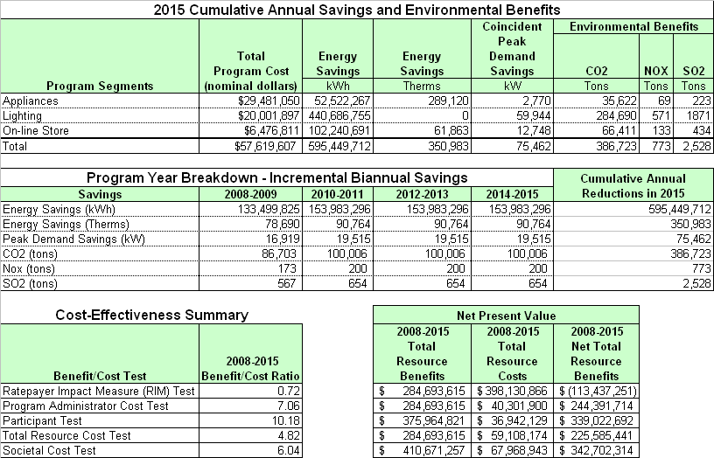

6.2 Residential Gas and Electric HVAC
The Residential Gas and Electric HVAC (Heating Ventilation and Air Conditioning) Program included the measures listed in Table 6-3.
Table 6-3: Summary of Residential Gas and Electric HVAC Measures
HVAC Repair and Diagnostics
Quality Installation
Residential AC Tier 1
Residential A/C Tier 2
Air Source Heat Pump Tier 1
Air Source Heat Pump Tier 1
Ground Source Heat Pumps (GSHP)
Natural Gas Furnace Tier 1
Natural Gas Furnace Tier 2
Natural Gas Boiler
Duct Sealing

The Residential Gas and Electric HVAC Program had Total Resource Cost test results of 1.38 and net total resource benefits of over $23 million (net present value) as shown in Table 6-4 below.
Table 6-4: Summary of Impacts Residential Gas and Electric HVAC
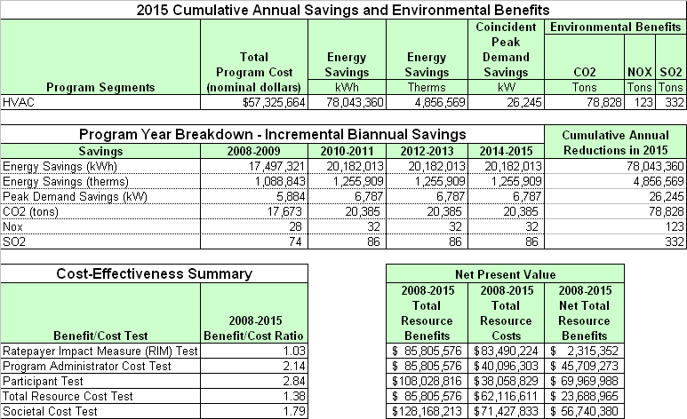

6.3 Residential Retrofit
The Residential Retrofit Program includes three approaches with an increasing number of measures applied to each approach. The three approaches are: 1. an on-line audit; 2. an on-site audit; and 3. a Home Performance with ENERGY STAR® (HPES) residential testing program. The measures offered in the on-line audit are also offered in the on-site audit and in the HPES. The additional measures offered in the on-site audit are also offered in the HPES. The measures offered through each of the three approaches are shown in Table 6-5 below.
Table 6-5: Summary of Residential Retrofit Measures
 | On-line Audit (257,000 homes) | On-Site Audit (23,400 homes) | HPES (13,500 homes)
Lighting
CFLs | X | X | X
Hardwired fixtures | X | X | X
Domestic Hot Water
Faucet Aerators | X | X | X
Low Flow Showerheads | X | X | X
DHW Tank Wrap |  | X | X
DHW Pipe Insulation |  | X | X
Hi Efficiency Elect hot water heater |  | X | X
Hi Efficiency Gas hot water heater |  | X | X
Building Envelope
Minor weatherization | X | X | X
Building sealing |  | X | X
Building Insulation, Windows and Sealing |  |  | X
Hi E Windows |  |  | X
Window Treatment |  |  | X
HVAC
Furnace Filters |  | X | X
Room AC |  | X | X
Residential AC Tier 1 |  |  | X
Residential A/C Tier 2 |  |  | X
Air Source Heat Pump Tier 1 |  |  | X
Air Source Heat Pump Tier 1 |  |  | X
Natural Gas Furnace Tier 1 |  |  | X
Natural Gas Furnace Tier 2 |  |  | X
Natural Gas Boiler |  |  | X
Quality Install |  |  | X
HVAC Diagnostic and Repair |  |  | X
Duct Sealing |  |  | X
Appliances
Clothes Washers |  |  | X
Refrigerators |  |  | X
Compact Refrigerators |  |  | X
Freezers |  |  | X
Room Air conditioners |  |  | X
Dishwashers |  |  | X
Dehumidifiers |  |  | X
The Residential Retrofit Program had Total Resource Cost test results of 1.25 and net total resource benefits of over $10 million (net present value) as shown in Tables 6-6 below.
Table 6-6: Summary of Impacts Residential Retrofit
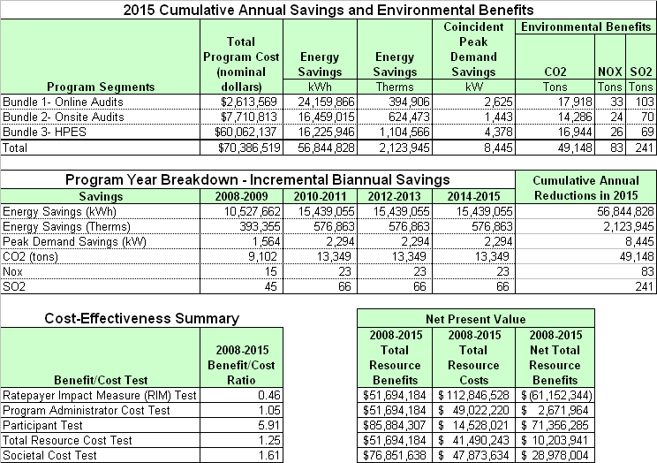

6.4 Residential New Construction
The Residential New Construction Program applied 75, 80 and 85 percent of the Energy Star® Homes standard. The costs and impacts for each level were determined using a measure analysis sheet and a weighted average for the three levels was applied.

The Residential New Construction Program had Total Resource Cost test results of 1.64 and net total resource benefits of almost $11 million (net present value) as shown in Table 6-7 below.
Table 6-7: Summary of Impacts Residential New Construction
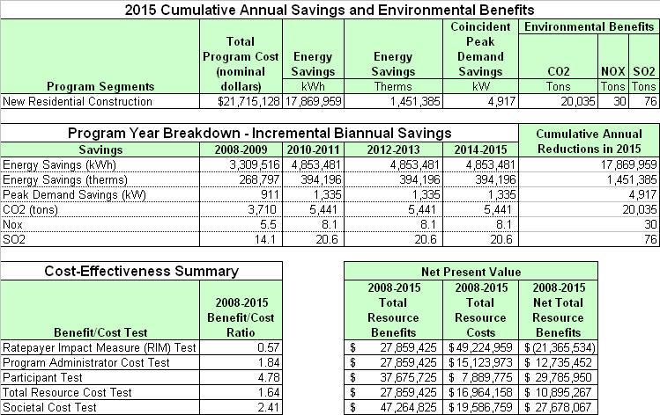

6.5 Low Income
The Low Income Program included the measures in Table 6-8.
Table 6-8: Summary of Low Income Program Measures
Lighting | Building Envelope | Domestic Hot Water
CFLs | High Efficiency Windows | Faucet Aerators
Hardwired Fixtures | Roof Insulation | Low Flow Showerheads
HVAC | Wall Insulation | DHW Tank Wrap
HVAC Tune-Ups | Appliances | DHW Pipe Insulation
High Efficiency Air Conditioning | Refrigerators

The Low Income Program had Total Resource Cost test results of 1.14 and total net resource benefits of almost $3 million (net present value) as shown in Table 6-9 below.
Table 6-9: Summary of Impacts Low Income Program

6.6 Small Commercial
The Small Commercial Program is directed at customers with a connected load of less than 60 kW. The program consisted of two approaches: 1. rebate and 2. direct install. The same measures were used for each approach as shown in Table 6-10 below.
Table 6-10: Summary of Small Commercial Measures
Lighting | HVAC | Refrigeration
CFLs | Split Package Air Conditioner (SEER) | High Efficiency Ice Makers
Premium Fluorescent Fixture with High Performance T8 Lamps and Electronic Ballast | Split Package Air Conditioner (EER) | Strip Curtains
LED Exit Signs | Split Package Heat Pump (EER) | Anti Sweat Heater Controls
Outdoor Lights | Energy Efficient Packaged Heat  and Air Conditioning Units | Vending Machine Controls
Occupancy Sensors – Fluorescent Fixtures | Motors | Night Covers
 | Open Drip Proof Motors
 | Totally Enclosed Fan-Cooled Motors

The Small Commercial Program had Total Resource Cost test results of 2.29 and net total resource benefits of over $63 million (net present value) as shown in Table 6-11 below.
Table 6-11: Summary of Impacts Small Commercial Program
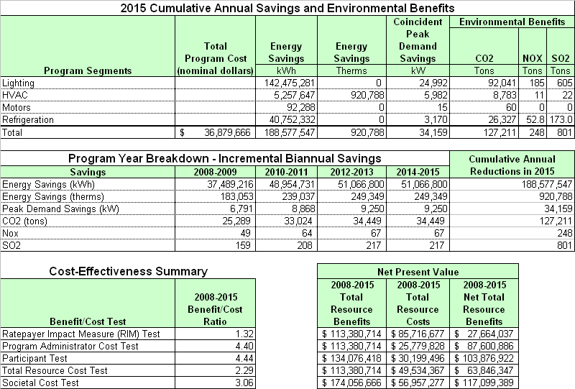
Appendix A: Program Benefit / Cost Analysis Details
Example printouts from the benefit/cost analysis workbooks for each program are included in these appendices. Reviewers are advised that some of the spreadsheets included in the benefit/cost analysis workbooks are very large and it is not possible to print legible copies of the entire spreadsheet. Thus, the examples on the following pages are included to indicate the type and format of the data and results that are included in the workbooks. However, it is necessary to refer to the electronic files in order to access all of the information contained in the workbooks.

Appendix A.1: Energy Star Products Benefit / Cost Analysis
Cost Effectiveness Tests:

Annual Program Savings and Costs (1):

Annual Program Savings and Costs (2) /
Cumulative Savings Values by Measure Life:

Measure Savings and Costs (1):
Measure Savings and Costs (2):
Appendix A.2: Residential HVAC Benefit / Cost Analysis
Cost Effectiveness Tests:

Annual Program Savings and Costs:

Measure Savings and Costs:

Appendix A.3: Residential Retrofit Benefit / Cost Analysis
Cost Effectiveness Tests:
Annual Program Savings and Costs (1):
Annual Program Savings and Costs (2):
Annual Program Savings and Costs (3) /
Cumulative Savings Values by Measure Life – Online Audits:
Annual Program Savings and Costs (4) /
Cumulative Savings Values by Measure Life – Onsite Audits:

Annual Program Savings and Costs (5) /
Cumulative Savings Values by Measure Life – HPES:
Measure Savings and Costs (1) – Online Audits:

Measure Savings and Costs (2) – Onsite Audits:

Measure Savings and Costs (3) – HPES:
Measure Savings and Costs (4) – HPES (cont.):
Appendix A.4: Residential New Construction Benefit / Cost
Cost Effectiveness Tests:
Annual Program Savings and Costs:

Measure Savings and Costs:

Appendix A.5: Low Income Benefit / Cost Analysis
Cost Effectiveness Tests:
Annual Program Savings and Costs:

Measure Savings and Costs:

Appendix A.6: Small Commercial Benefit / Cost Analysis
Cost Effectiveness Tests:
Annual Program Savings and Costs (1):
Annual Program Savings and Costs (2) /
Cumulative Savings Values by Measure Life:

Measure Savings and Costs:

Appendix B: Measure Analysis Spreadsheets (MAS)

Appendix B.1: Residential MAS

Air Conditioners:

Boilers:

Bounty Fridge and Freezers:

Clothes Washers:

Convection Ovens:

Dehumidifier:

Dishwashers:

Duct Sealing:

Energy Star New Homes:

Faucet Aerators and Low Flow Showerheads:

Freezers:

Furnaces:

Ground Source Heat Pumps:

Holiday Lights:

Heat Pumps:

HVAC:

Lighting CFL (Hardwired):

Lighting CFL (Screw In):

Night Lights:

Occupancy Sensor Power Bars:

Pipe Insulation:

Quality Installation / HVAC Repair and Diagnostics:

Refrigerators:

Residential Retrofit:

Room AC:

Tank Wrap:

Window Replacement:

Appendix B.2: Commercial MAS

Gas Split Package Efficient Heat and Air Conditioners:

Lighting-Exit Signs:

Lighting-CFL (Hardwired):

Lighting-Occupancy Sensors:

Lighting-Outdoor Lighting:

Lighting-Premium T8 Lighting:

Motors-Open Drip Proof:

Motors-Totally Enclosed Fan-Cooled:

NonRes Split Packaged AC EER:

NonRes Split Packaged AC SEER:

NonRes Split Packaged HP EER:

Refrigerator-Anti Sweat Heater Controls:

Refrigerator-High Efficiency Ice Makers:

Refrigerator-Strip Covers and Night Curtains:

Refrigerator-Vending Machine Controls:

Appendix C: Measure Cost Data Summary

Measure Cost Data Summary (1) – Residential:
Measure Cost Data Summary (2) – Commercial:
Appendix D: Program Administration Cost Data Summary
Appendix E: Market Penetration Summary

Residential Measures:
Commercial Measures:

Appendix F: Building Energy Simulation Model Specifications

The manual can be downloaded at http://www.energy.ca.gov/greenbuilding/documents/background/07-J_CPUC_STANDARD_PRACTICE_MANUAL.PDF
See http://eega.cpuc.ca.gov/deer/
Measure Life Report, Residential and Commercial/Industrial Lighting and HVAC Measures, GDS Associates, Inc., June 2007. available at http://www.neep.org/about/measure_life_GDS.pdf
Available at http://docs.cpuc.ca.gov/published/Final_decision/11474-13.htm#P428_33012
The BGE rates used remained constant throughout the analysis period.
ACEEE September 2007, Energy Efficiency Resource Standards around the U.S. and the World, see http://www.aceee.org/energy/state/6pgEERS.pdf
Baltimore Area Housing Statistics 2000 Census, available at http://www.census.gov/census2000/states/md.html
Free-ridership is the proportion of in-program impacts (e.g., energy savings) that would have occurred in the absence of the program, or without program incentives.
Spillover is the proportion of outside-program impacts (e.g., energy savings) that occurred as a result of the program, but without any program incentives.
See http://www.federalreserve.gov/releases/h15/data/Annual/H15_FF_O.txt

